ROAD ACCIDENT REPORT SQL QUERIES

Total accident

select sum(number_of_casualties) as Total_Accidents

from road_accident

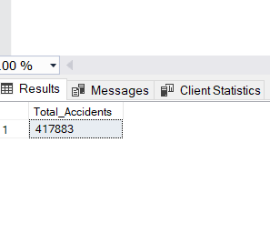

CY Casualties

select sum(number_of_casualties) as CY_Casualties

from road_accident

where year(accident_date) = '2022'

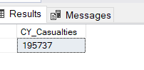

CY Accidents

select count(distinct accident_index) as CY_Accidents

from road_accident

where year(accident_date) ='2022'

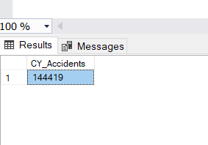

CY fatal casualties

select sum(number_of_casualties) as CY_Fatal_Casualties

from road_accident

where year(accident_date) ='2022'

and accident_severity = 'Fatal'

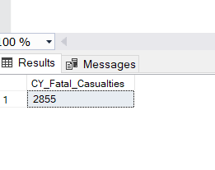

cy serious casualties

select sum(number_of_casualties) as CY_Serious_Casualties

from road_accident

where year(accident_date) ='2022'

and accident_severity = 'Serious'

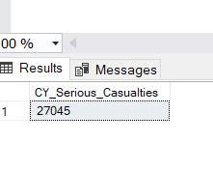

CY slight casualties

select sum(number_of_casualties) as CY_Slight_Casualties

from road_accident

where year(accident_date) ='2022'

and accident_severity = 'Slight'

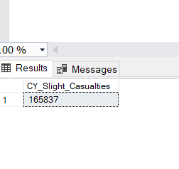

Total fatal casualties

select sum(number_of_casualties) as Total_Fatal_Casualties

from road_accident

where accident_severity = 'Fatal'

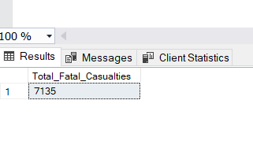

Total serious casualties

select sum(number_of_casualties) as Total_Serious_Casualties

from road_accident

where accident_severity = 'Serious'

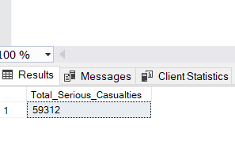

Total slight casualties

select sum(number_of_casualties) as Total_Slight_Casualties

from road_accident

where accident_severity = 'Slight'

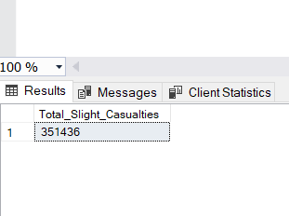

PCT for fatal

select cast(sum(number_of_casualties)as decimal (10,2)) * 100 /

(select cast(sum(number_of_casualties)as decimal (10,2)) from road_accident)as Percentage_of_Fatal_Total

from road_accident as Percentage_of_Total

where accident_severity ='Fatal'

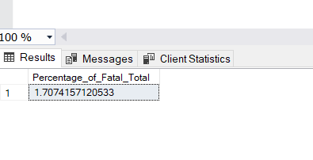

PCT for serious

select cast(sum(number_of_casualties)as decimal (10,2)) * 100 /

(select cast(sum(number_of_casualties)as decimal (10,2)) from road_accident)as Percentage_of_Serious_Total

from road_accident as Percentage_of_Total

where accident_severity ='Serious'

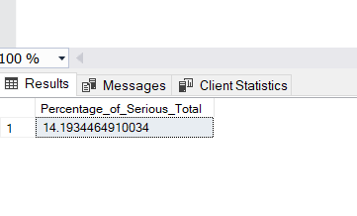

PCT for slight

select cast(sum(number_of_casualties)as decimal (10,2)) * 100 /

(select cast(sum(number_of_casualties)as decimal (10,2)) from road_accident)as Percentage_of_Slight_Total

from road_accident as Percentage_of_Total

where accident_severity ='Slight'

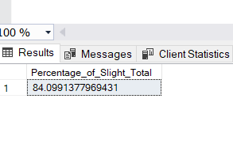

CY vs PY Monthly Trend

select DATENAME( month, accident_date) as Month_Name,

sum(number_of_casualties) as CY_Casualties

from road_accident

where year (accident_date) = '2022'

group by DATENAME( month, accident_date)

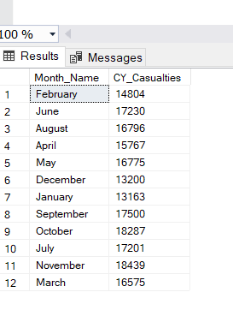

select DATENAME( month, accident_date) as Month_Name,

sum(number_of_casualties) as PY_Casualties

from road_accident

where year (accident_date) = '2021'

group by DATENAME( month, accident_date)

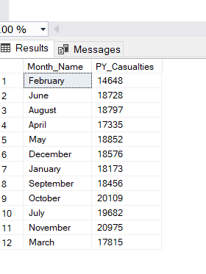

Road type casualties

select road_type, sum(number_of_casualties) as CY_Casualties

from road_accident

where year(accident_date) = '2022'

group by road_type

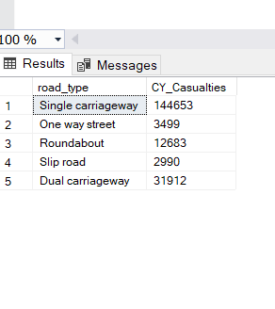

select road_type, sum(number_of_casualties) as PY_Casualties

from road_accident

where year(accident_date) = '2021'

group by road_type

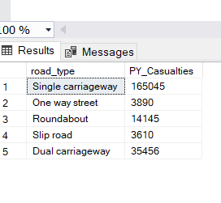

Urban and rural area casualties (cy)

select urban_or_rural_area, sum(number_of_casualties) as CY_Casualties

from road_accident as CY_Casualties

where year(accident_date) = '2022'

group by urban_or_rural_area

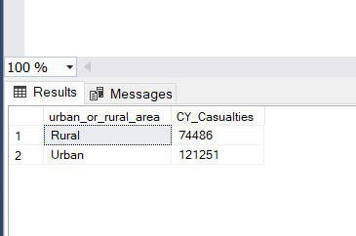

(py)

select urban_or_rural_area, sum(number_of_casualties) as PY_Casualties

from road_accident as PY_Casualties

where year(accident_date) = '2021'

group by urban_or_rural_area

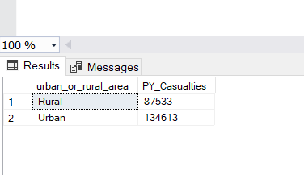

PCT For Urban and Rural (CY)

select urban_or_rural_area, CAST (sum(number_of_casualties) AS DECIMAL(10,2))* 100 /

(select CAST (sum(number_of_casualties) AS DECIMAL(10,2)) from road_accident where year(accident_date) = '2022')

AS Percentage_of_Total

from road_accident

where year(accident_date) = '2022'

group by urban_or_rural_area

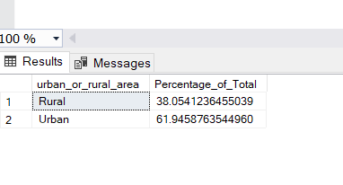

For PY

select urban_or_rural_area, CAST (sum(number_of_casualties) AS DECIMAL(10,2))* 100 /

(select CAST (sum(number_of_casualties) AS DECIMAL(10,2)) from road_accident where year(accident_date) = '2021')

AS Percentage_of_Total

from road_accident

where year(accident_date) = '2021'

group by urban_or_rural_area

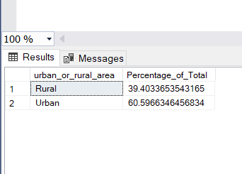

Total casualties

elect urban_or_rural_area, sum(number_of_casualties) as Total_Casualties,

CAST (sum(number_of_casualties) AS DECIMAL(10,2))* 100 /

(select CAST (sum(number_of_casualties) AS DECIMAL(10,2)) from road_accident )

AS Percentage_of_Total

from road_accident

group by urban_or_rural_area

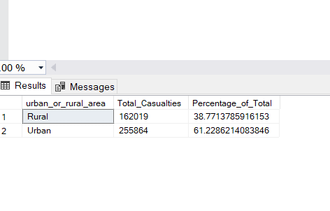

Top 10 location by no of casualties

select top 10 local_authority, sum(number_of_casualties) as Total_Casualties

from road_accident

group by local_authority

order by Total_Casualties desc

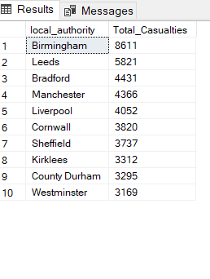

Casualties by vehicle type

select vehicle_type as Vehicle_Type,

sum(number_of_casualties) as Total_Casualties

from road_accident

group by Vehicle_Type

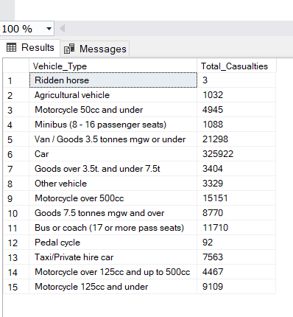

casualties by light condition

select light_conditions,

sum(number_of_casualties) as Total_Casualties

from road_accident

group by light_conditions

